Topic 6.9: Permutations of an Array

Question

Given an array nums of distinct integers, return all the possible permutations. You can return the answer in any order.

Aim

To generate all possible permutations of a given array of distinct integers using backtracking.

Algorithm

* Initialize an empty list to store the permutations.
* Use a recursive function that:
* Builds a permutation by selecting elements one by one.
* Ensures that an element is not used more than once in the current permutation.
* When a permutation is complete (length equals n), store it in the result.
* Backtrack after exploring each possibility to try other options.
* Return the list of all permutations.

Output

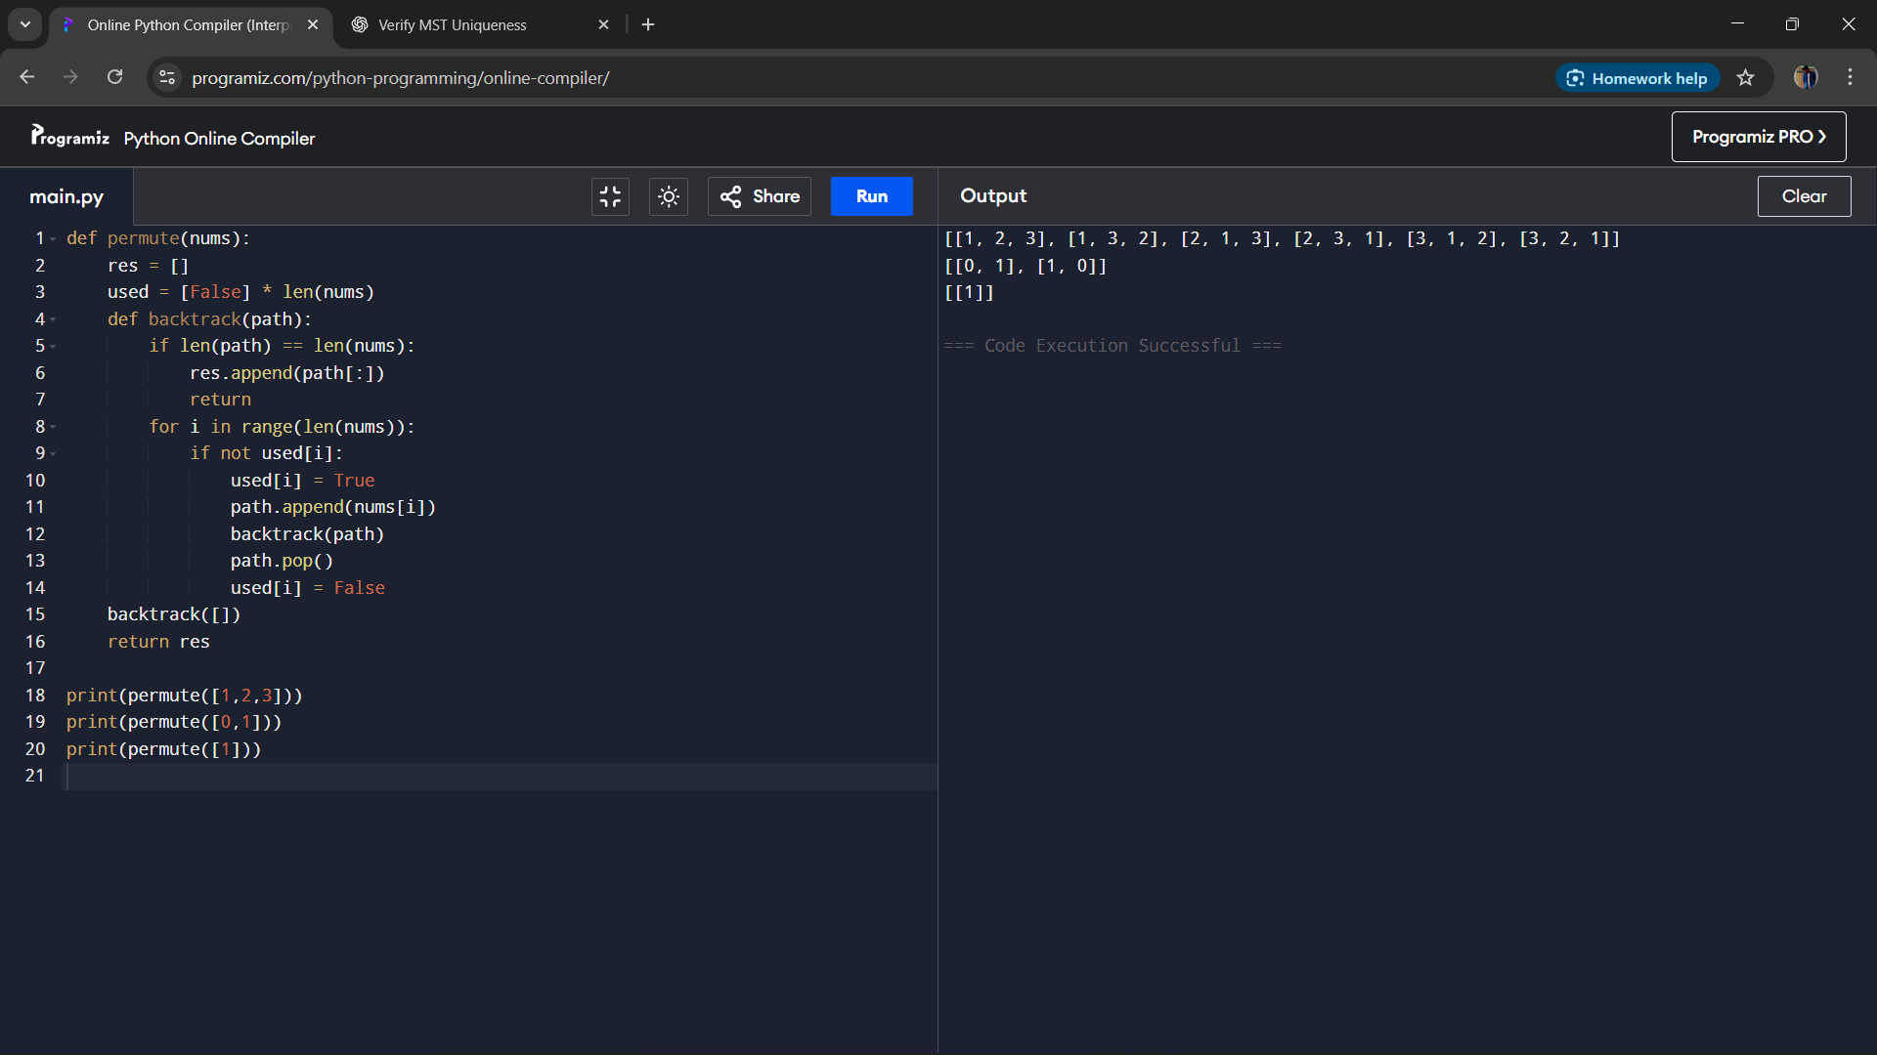

Result

The program generates all possible permutations of an array of distinct integers in any order.

Performance Analysis

Time Complexity: O(n × n!), since there are n! permutations and each takes O(n) time to construct.

Space Complexity: O(n) for recursion stack and temporary storage.